Elements of Report.
Apart from that, we’ll also share some basic tips when it comes to report formatting.
Sounds interesting?
Let’s get into it.

Table of Contents
6 Types of Reports
The Report Writing Format Outline
Element #1: Title
Element #2: Table of Contents
Element #3: Summary
Element #4: Introduction
Element #5: Body
Element #6: Conclusion
Element #7: Recommendations
Element #8: Appendices
The Best Report Writing Format Tips
Sample Report in Standard Report Writing Format

6 Types of Reports
There are a selection of different reports you might need to create. Each of these will follow a similar reporting writing format to what we've covering in this post.

1. Annual Reports
The first type of report we'll cover is an annual report. This will typically round up a business's year of progress and performance to let supervisors and team members know how the company did.
It can include anything from website analytics to sales profits, depending on who the report is meant for.
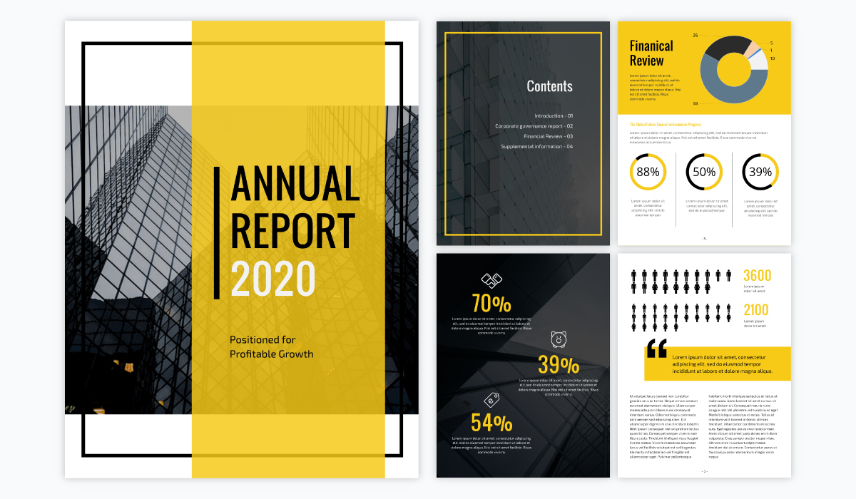
Customize this annual report template and make it your own!Edit and Download

2. Weekly Reports
One report that is helpful to provide your team is a weekly report based on your progress in various projects and goals. This can be a simple one-pager, or a more in-depth report with specific updates.
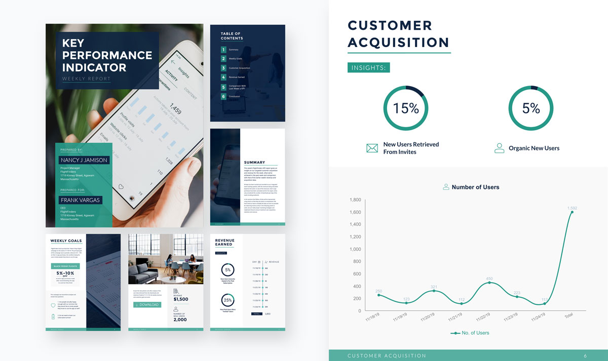
Customize this weekly report template and make it your own!Edit and Download

3. Project Reports
Keep clients and team members up-to-date on the status of various projects you're working on by providing them with a project report. This can include a timeline of your report progress and the deadline for each segment to keep everyone on the same page.
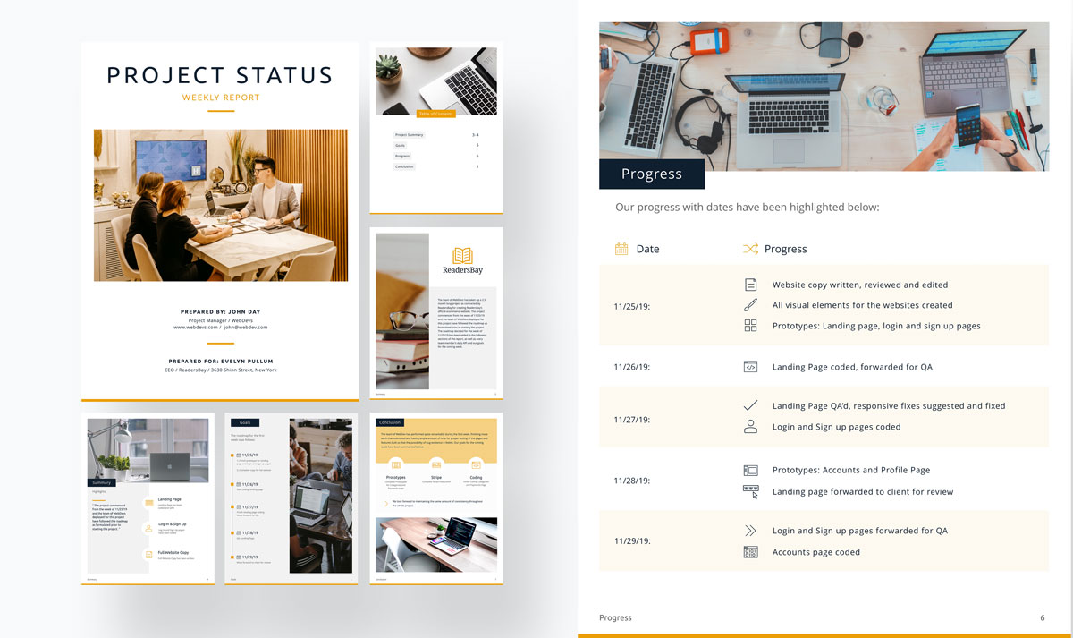
Customize this report template and make it your own!Edit and Download

4. Sales/Marketing Reports
It's essential to keep your team updated on how your sales and/or marketing strategies are going. Put together graphs showing profit margins, increases in engagement and more.
These types of reports are also a great way to determine whether your strategies are working or if they need some tweaking in the future.
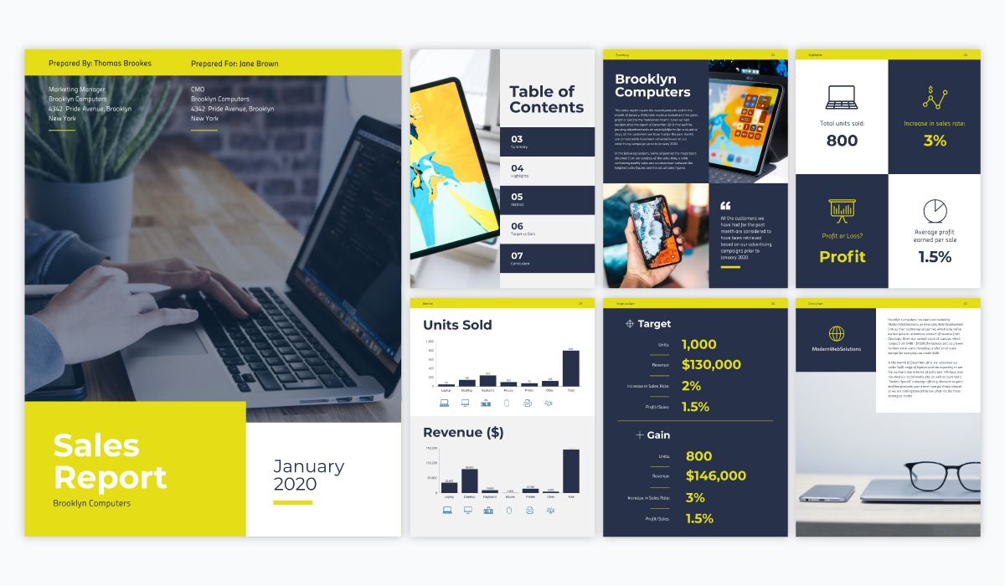
Customize this report template and make it your own!Edit and Download

5. Research Report
Sometimes if you need to do some in-depth research, the best way to present that information is with a research report. Whether it's scientific findings, data and statistics from a study, etc., a research report is a great way to share your results.
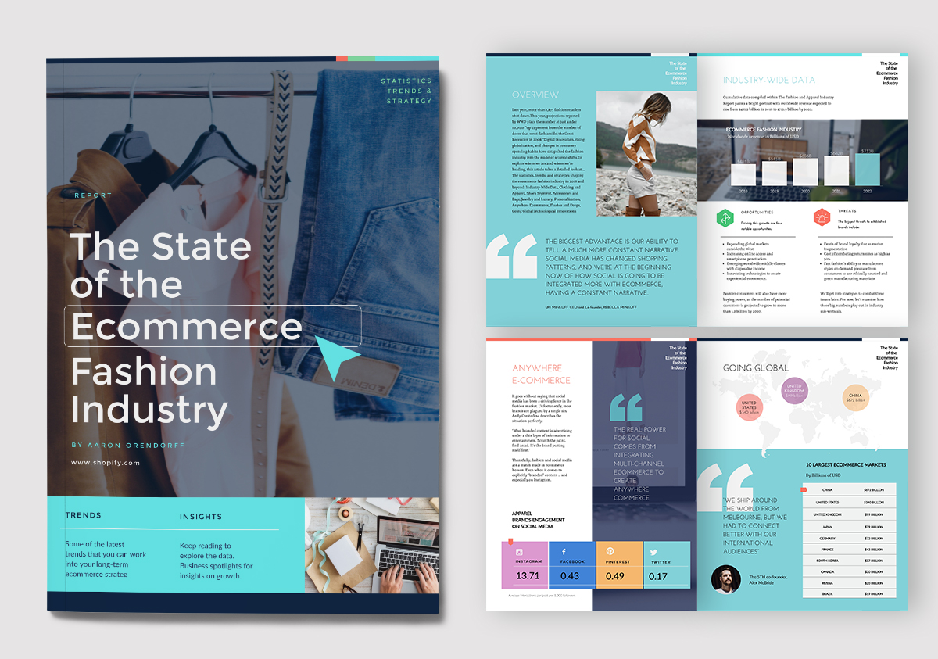
Customize this research report template and make it your own!Edit and Download

6. Academic Report
An academic report is one created for a class, often in graduate or undergraduate university. This follows a formal writing style and dives into a topic related to the student's academic studies.
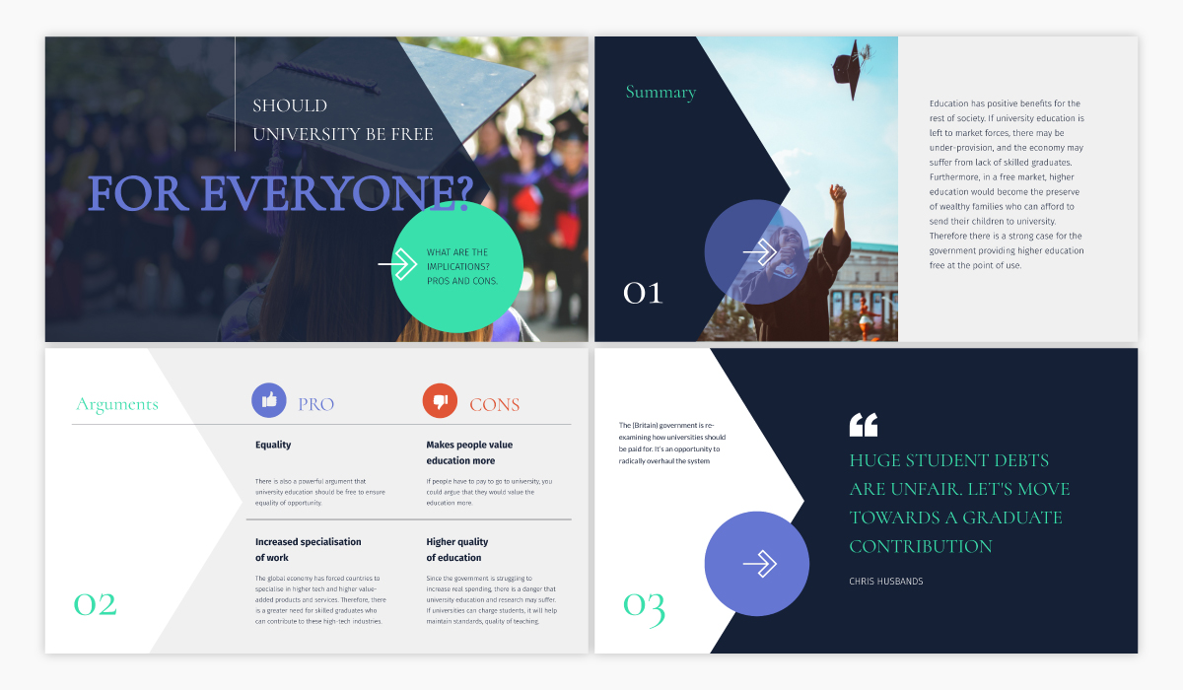
Customize this presentation template and make it your own!Edit and Download

The Report Writing Format Outline
Every good report needs to start with an outline. Use the outline below to set yourself up for success when putting all your information together for the final report.
At each point of the outline, use one or two sentences to describe what will go in there. It doesn’t need to say much, just an idea for you to follow later. Input some design ideas for the overall design as well.
For example, in the Table of Contents section, simply add that you want it to only cover one page or slide, make a note if you’d like to add the pages for only the main sections or maybe also the subsections.
In the Appendices section, list all the links to the sources you used and add on as you do more research. Every source you reference in your report must be listed here.
The most important part of your outline is the Body section. In there, create an internal outline of sections and subsections that you can follow later when writing.
Copy this outline into your document as a template.
After you’ve drafted the outline, it’s time to put together all of the content into the report. The outline we provided above is the only report writing format you’ll ever need. You can add sections if needed but don’t take any away.
Let’s take a look at every section in detail.

Element #1: Title
Customize this report template and make it your own!Edit and Download
The title of your report should be clear in its wording. It must say exactly what the report is about. Remember that this isn’t a novel. Include a subtitle if necessary, making sure the font size of each subtitle is smaller than the title.
In terms of design, your title can be designed as an inviting cover page. There needs to be a clear hierarchy in how the title looks.

Element #2: Table of Contents
Customize this report template and make it your own!Edit and Download
Always leave the Table of Contents page until the end. You can’t write a table of contents if you don’t know all of your page numbers yet.
However, if your Body outline already has each of your section and subsection titles defined, you can add those to the contents and leave the numbering for later.

Element #3: Summary
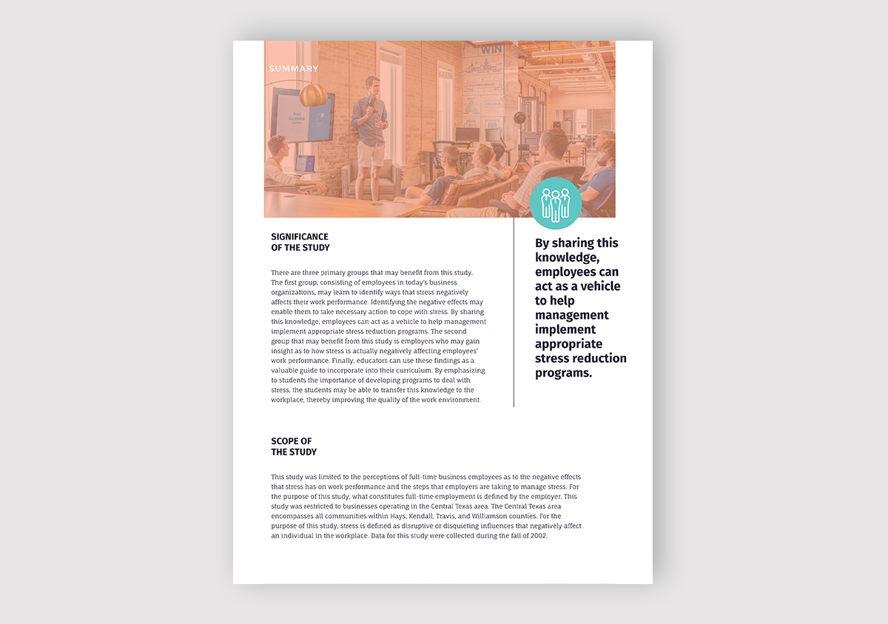
Customize this report template and make it your own!Edit and Download
Likewise, the summary of the report is best done after you’ve finished writing the report. You can draft a summary at the beginning to help you continue with the work, but you’ll definitely want to revisit it at the end.
A summary is a blurb of the entire report. It must include the purpose, the process and a snippet of the resolution.

Element #4: Introduction
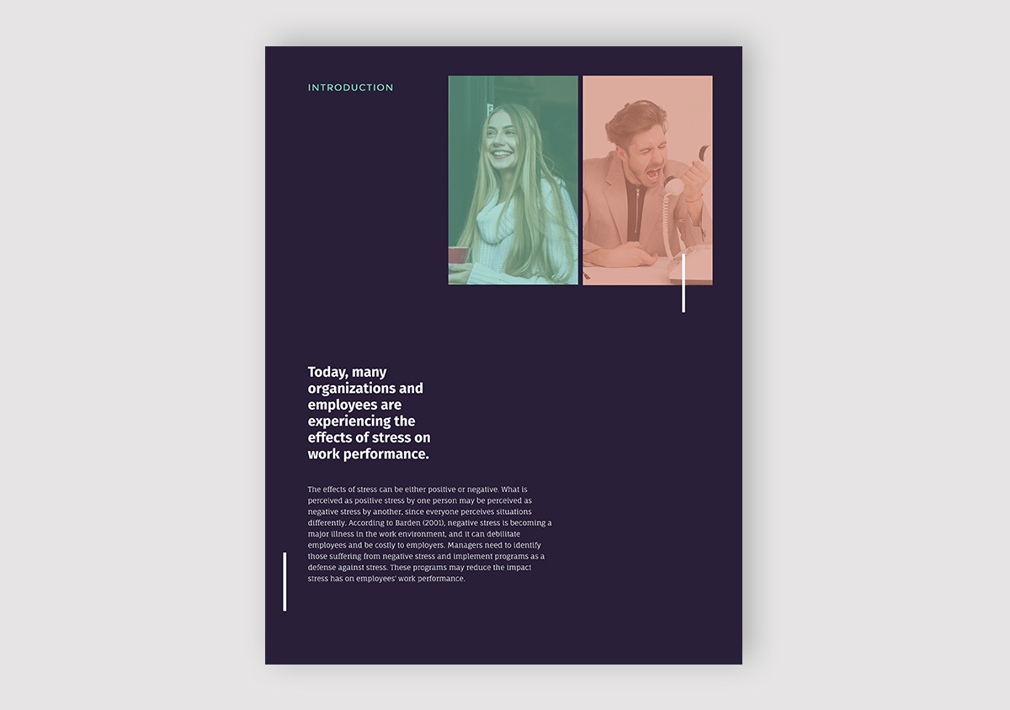
Customize this report template and make it your own!Edit and Download
In the introduction, state what the report is about and why it has been created. Depending on the length of your report, the introduction is a paragraph to an entire page long.
For example, one paragraph is enough for a social media report introduction while an entire page would be more suitable for an annual report.

Element #5: Body
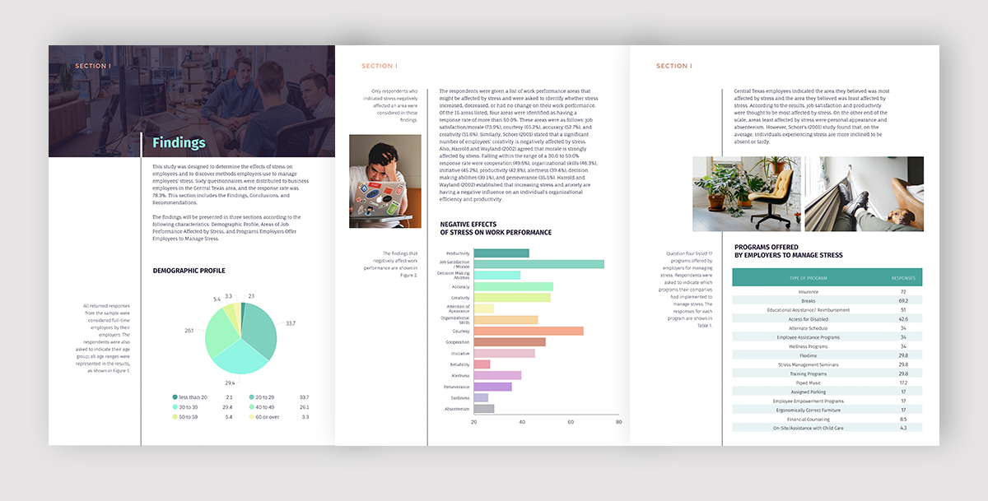
Customize this report template and make it your own!Edit and Download
The body of your report is where all the information is put together. Follow your initial outline to maintain consistent flow in the content creation. Write the body content as sections and subsections.
Furthermore, use bullet points and data visualization as visual cues. These will help your audience to better understand the content of your report.
Check out this video from Visme for some tips on visualizing all that data!

Element #6: Conclusion
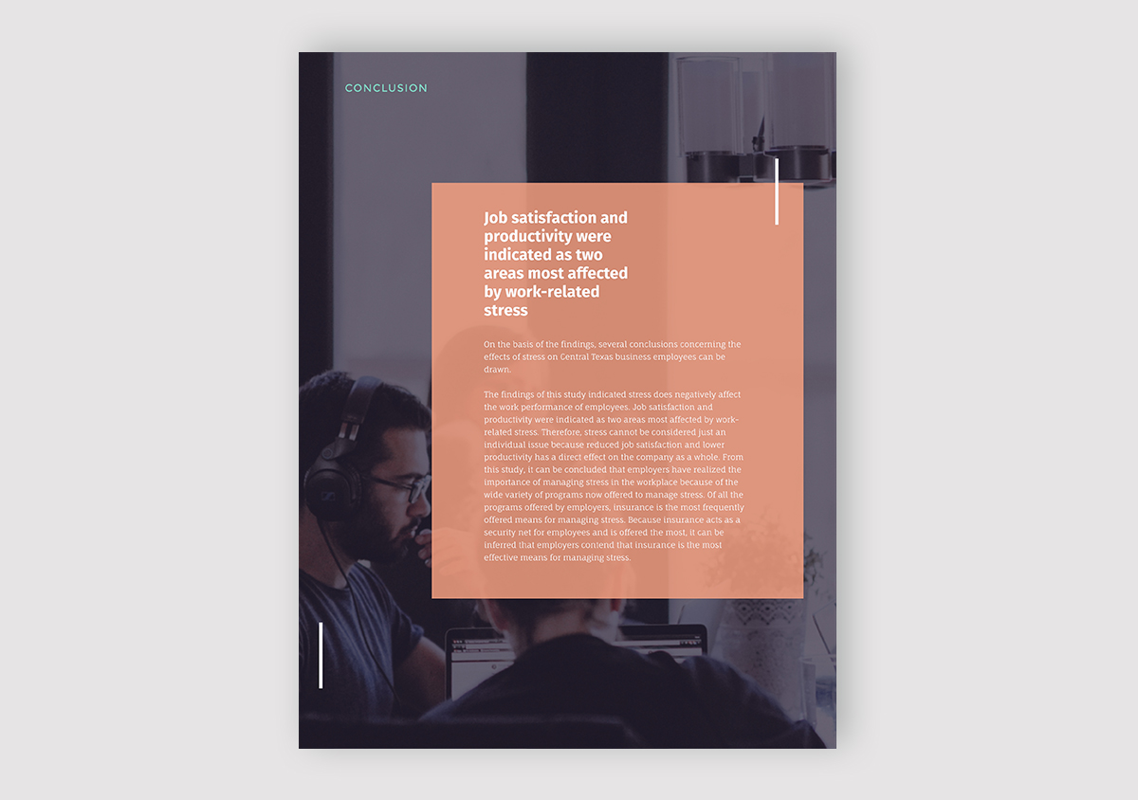
Customize this report template and make it your own!Edit and Download
Close your report with a well-crafted conclusion. Formulate it as a brief summary of what was covered within the report, and be sure to include a mention to the recommendations section and the resources in the appendix.

Element #7: Recommendations
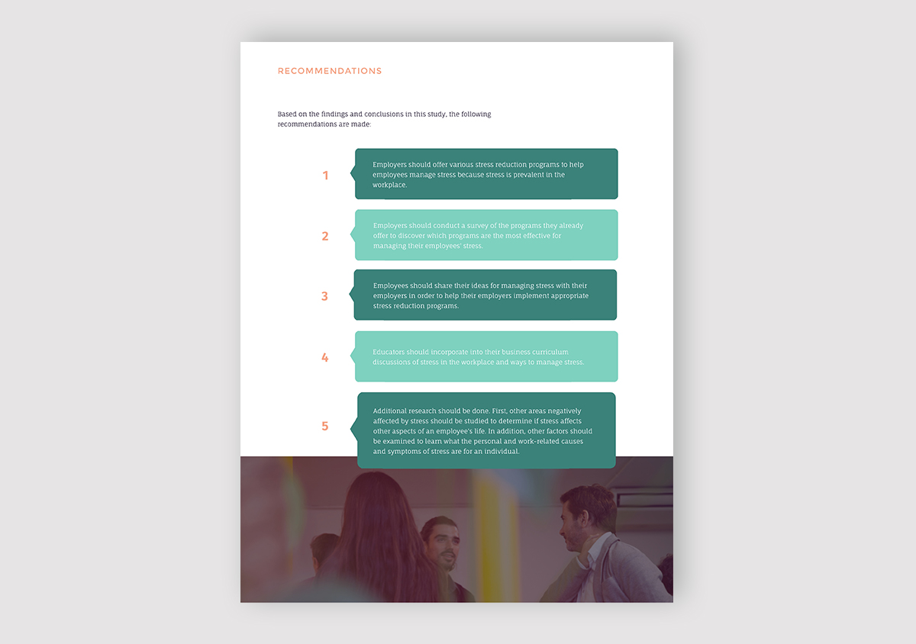
Customize this report template and make it your own!Edit and Download
Craft the recommendations section as a set of actionable steps with smart goals associated along with possible solutions. This section is irrelevant for school reports or book reports, but is essential in a business setting.

Element #8: Appendices
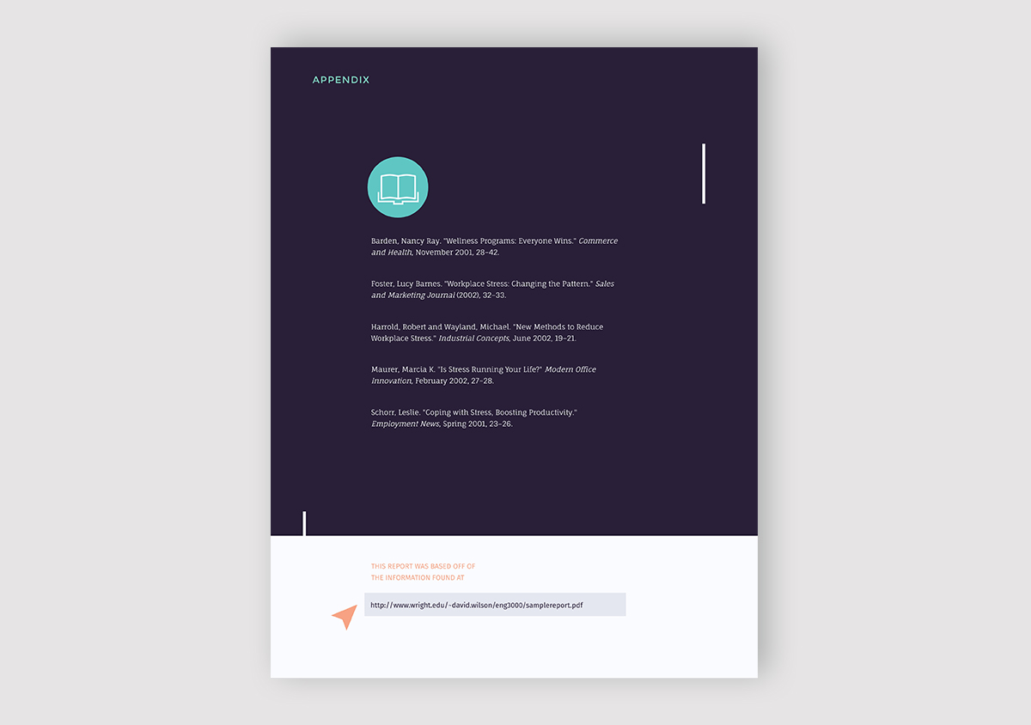
Customize this report template and make it your own!Edit and Download
This is the section where you list all your sources if it’s a research report. You should also add any links that are relevant to the report – or previous reports about the same topic.
You could even link an interactive version of the report you just created with Visme. Visme allows you to create interactive and animated documents that can be published to the web with a single click, offering a new dimension to your report.
A good rule of thumb when creating your appendices is to only add information that is relevant to the report or that you referenced when writing your report. Use reference annotations inside the report to link to the content in the appendix.
The report content used in this sample report design can be found here.

The Best Report Writing Format Tips
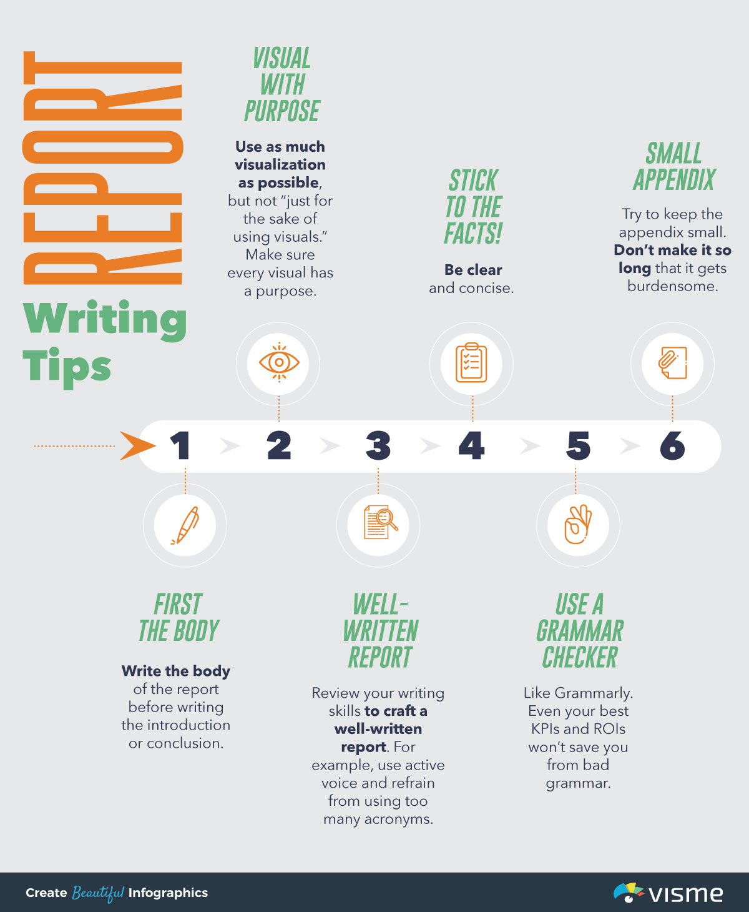

Looking to create a stand-out visual report?
- Choose from dozens of professionally designed templates
- Create animated charts and creatively visualize stats and figures
- Customize anything to fit your brand image and content needs
Sign up. It's free.
Following a report writing format is only one part of the process. You also need to be conscious of how you put the written content and the visuals together.
Here are some tips from the Visme team to help you make amazing reports.
- Write the body of the report before writing the introduction or conclusion.
- Use as much visualization as possible, but not “just for the sake of using visuals.” Make sure every visual has a purpose.
- Review your writing skills to craft a well-written report. For example, use active voice and refrain from using too many acronyms. Also, use simple language and stay away from word stuffing.
- Stick to the facts! Be clear and concise.
- Use a grammar checker like Grammarly. Even your best KPIs and ROIs won’t save you from bad grammar.
- Try to keep the appendix small. Don’t make it so long that it gets burdensome.

Sample Report in Standard Report Writing Format
Click through the image below to use this customizable template to create your report. It follows the standard report writing format so you won’t get confused or miss a section.
Here are some tips on using Visme templates and customizing the design.
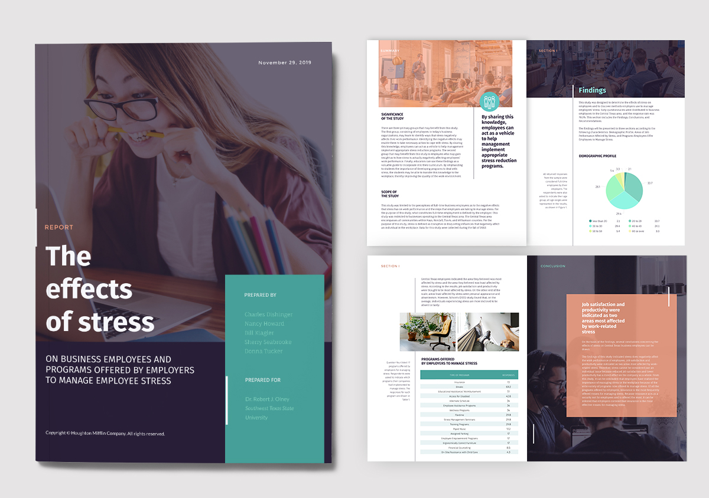
Customize this report template and make it your own!Edit and Download

Over to You
Hopefully, this post has helped you to better understand the best way to put together a report. Following a standard report writing format is just what you need to create engaging, memorable reports. Follow the tips above and you’ll never make a boring report again.

